Question 1

Question 2

data = [-0.4326 -1.6656 0.1253 0.2877 -1.1465 1.1909 1.1892 -0.0376 0.3273 0.1746];

mu = mean(data);

sigma = std(data);

lower = mu - 2.262\*sigma/sqrt(10)

lower = -0.6450

upper = mu + 2.262\*sigma/sqrt(10)

upper = 0.6475

Question 3

for i =1:1000

X = exprnd(10,5,1);

meanX(i) = mean(X);

end

figure;

histogram(meanX)

xlabel('Value')

ylabel('Counts')

set(gca,'fontsize',14)

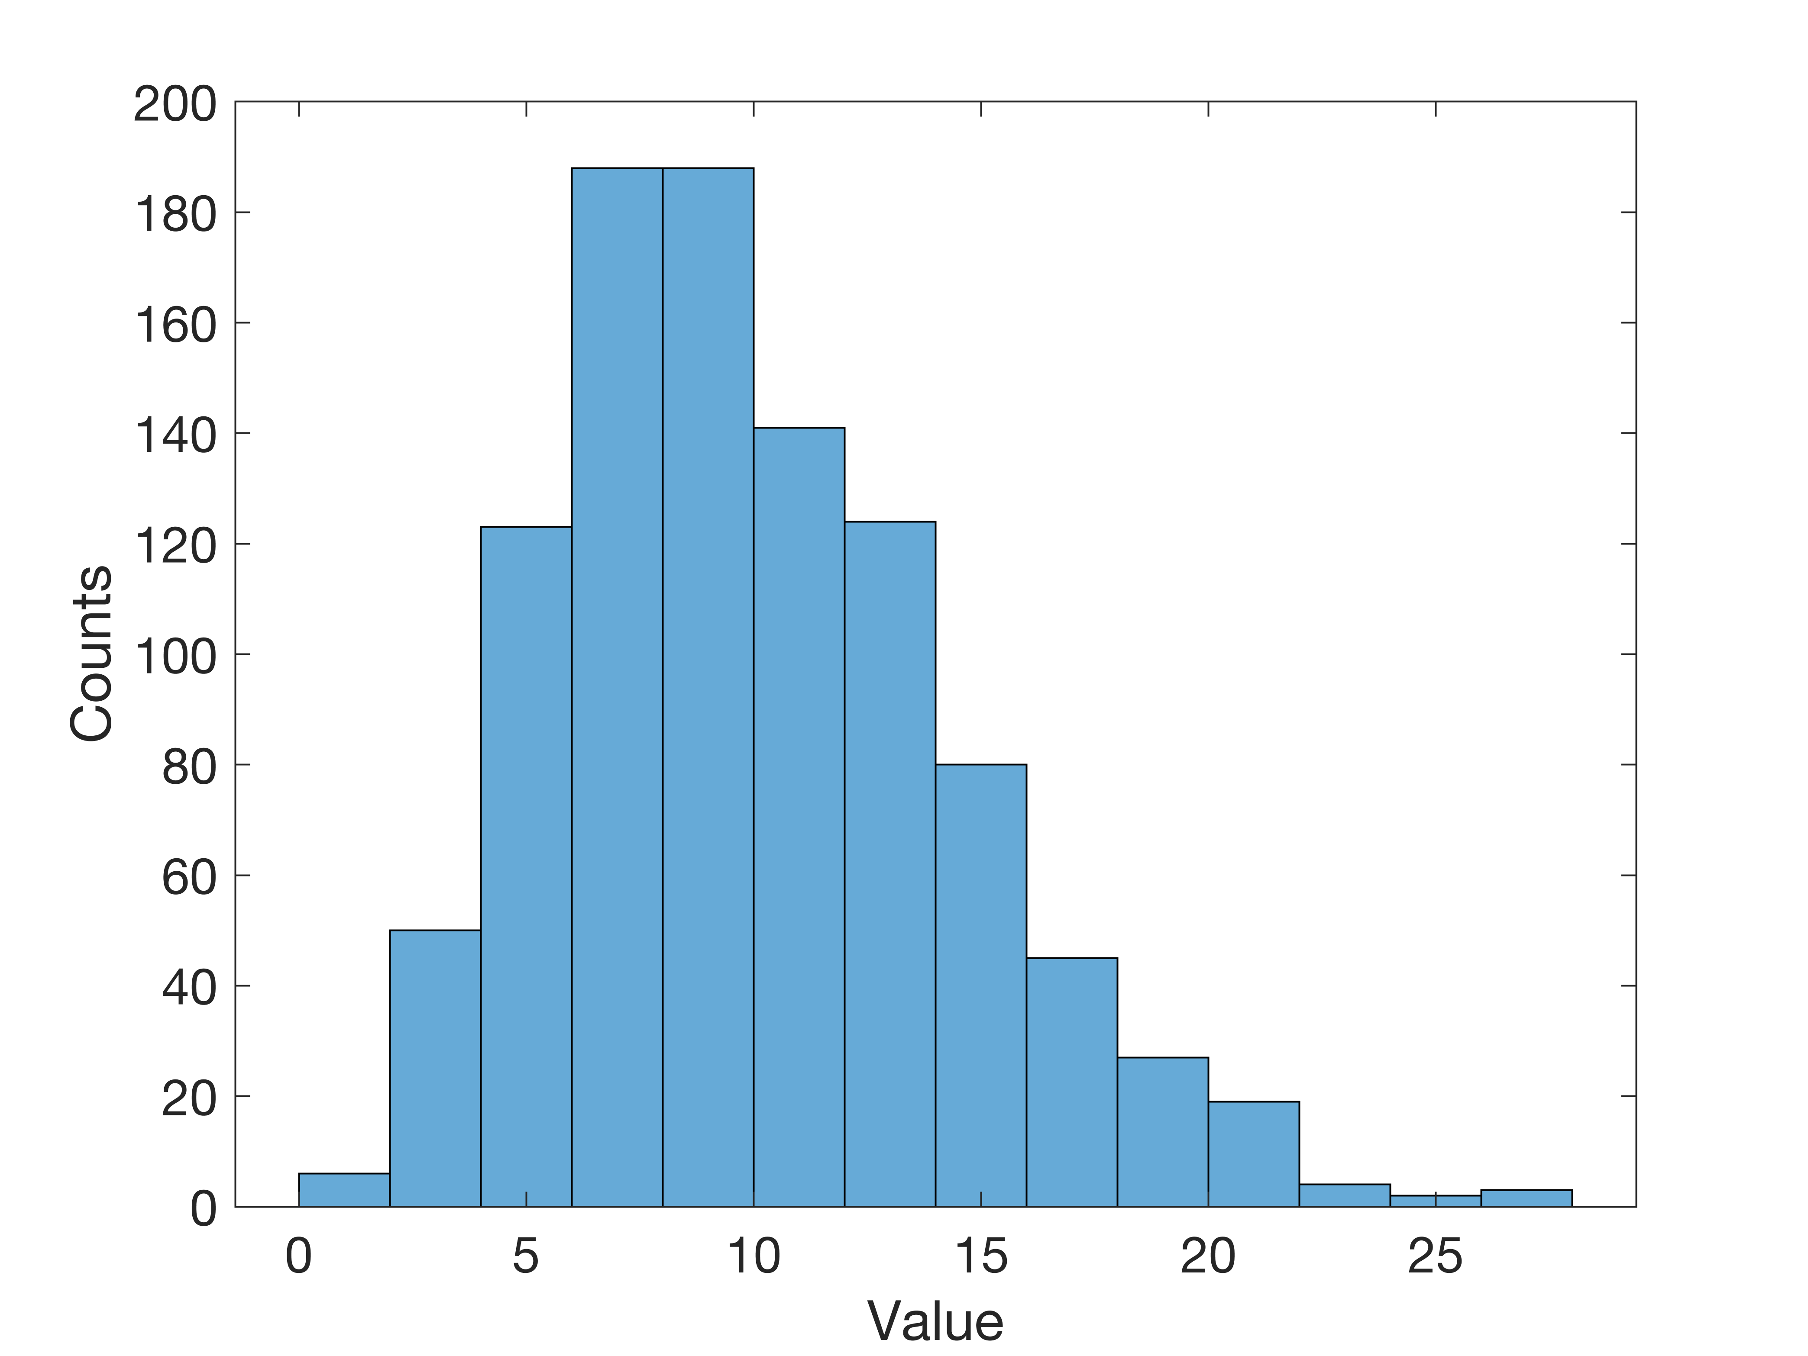

figure;

qqplot(meanX)

set(gca,'fontsize',14)

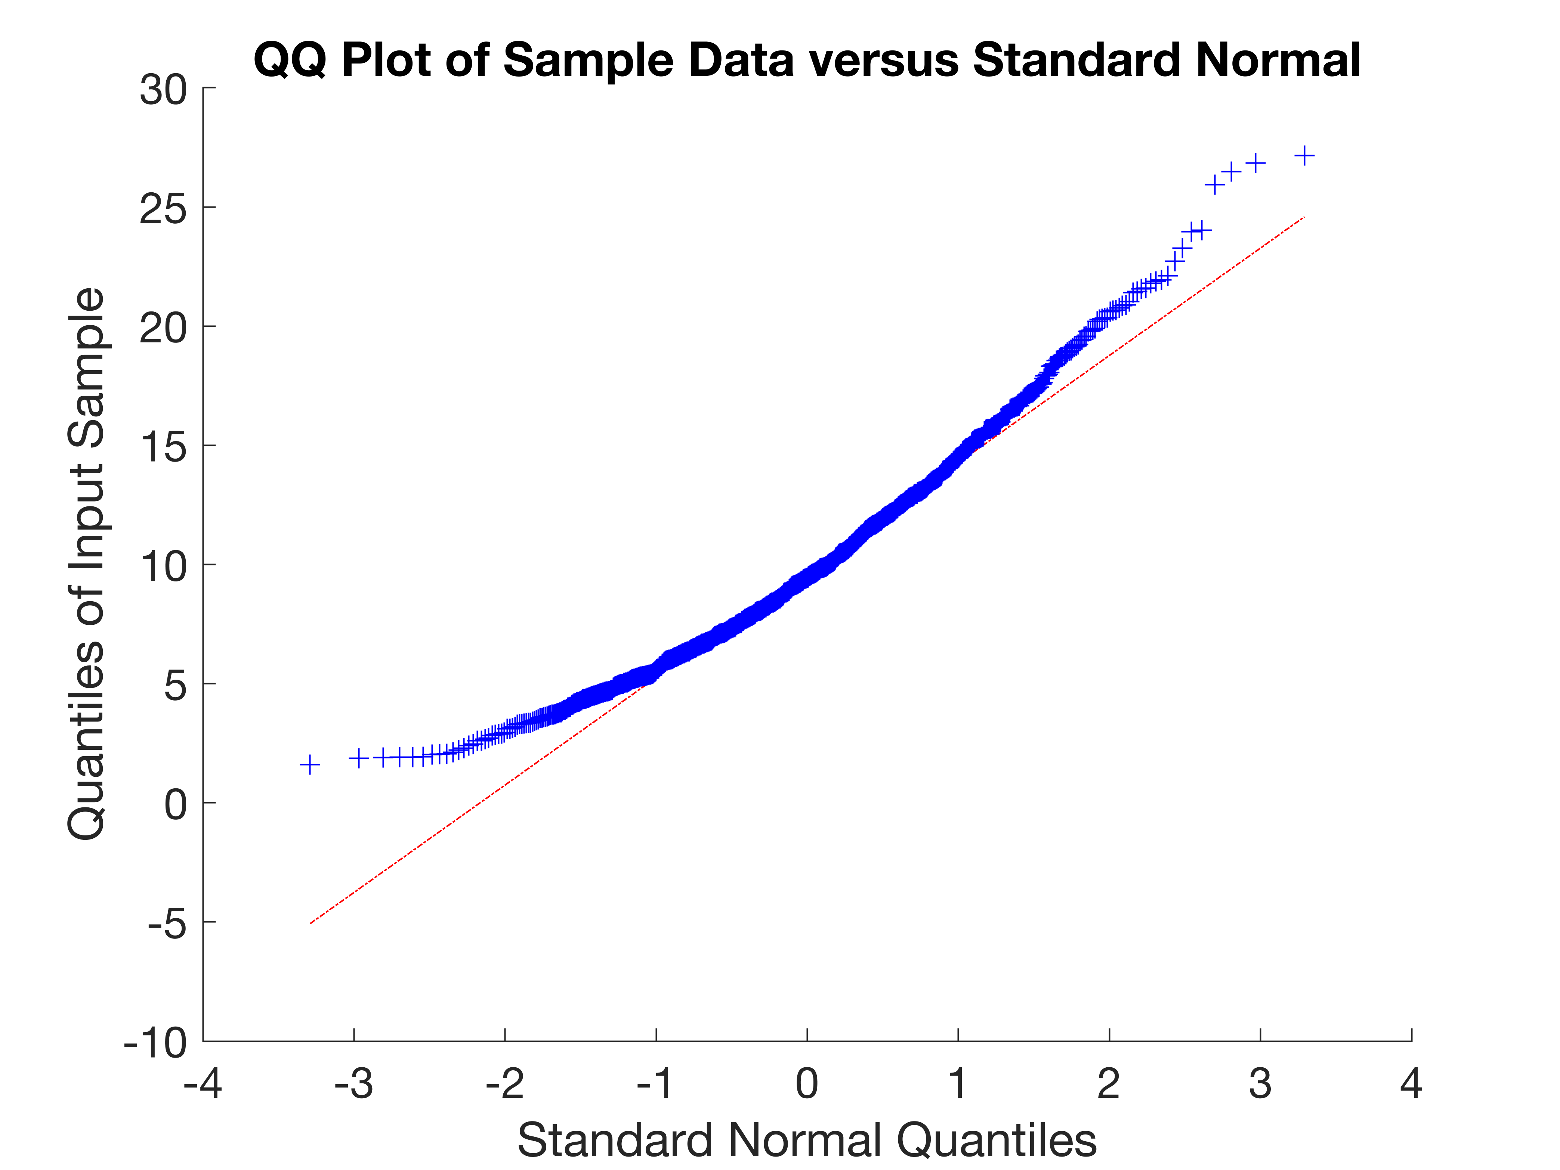

In this situation, the distribution of averages is not very close to the Gaussian distribution. But it should be close to the Gaussian distribution due to the central limit theory. This maybe induced by sample mean value is varied a lot since we only have 5 samples to calculate the mean value.

Question 4

for i =1:1000

X = exprnd(10,50,1);

meanX(i) = mean(X);

end

figure;

histogram(meanX)

xlabel('Value')

ylabel('Counts')

set(gca,'fontsize',14)

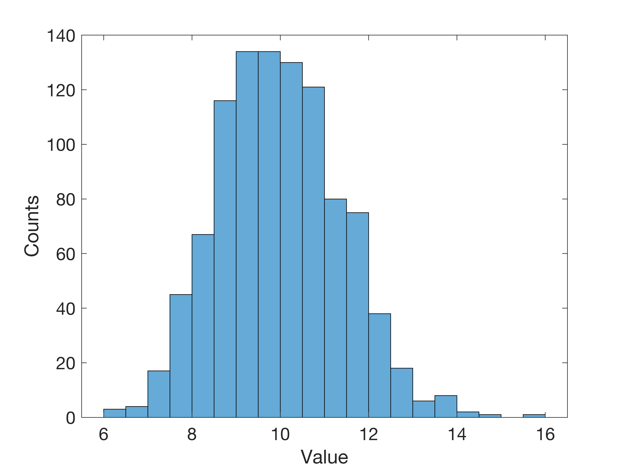

figure;

qqplot(meanX)

set(gca,'fontsize',14)

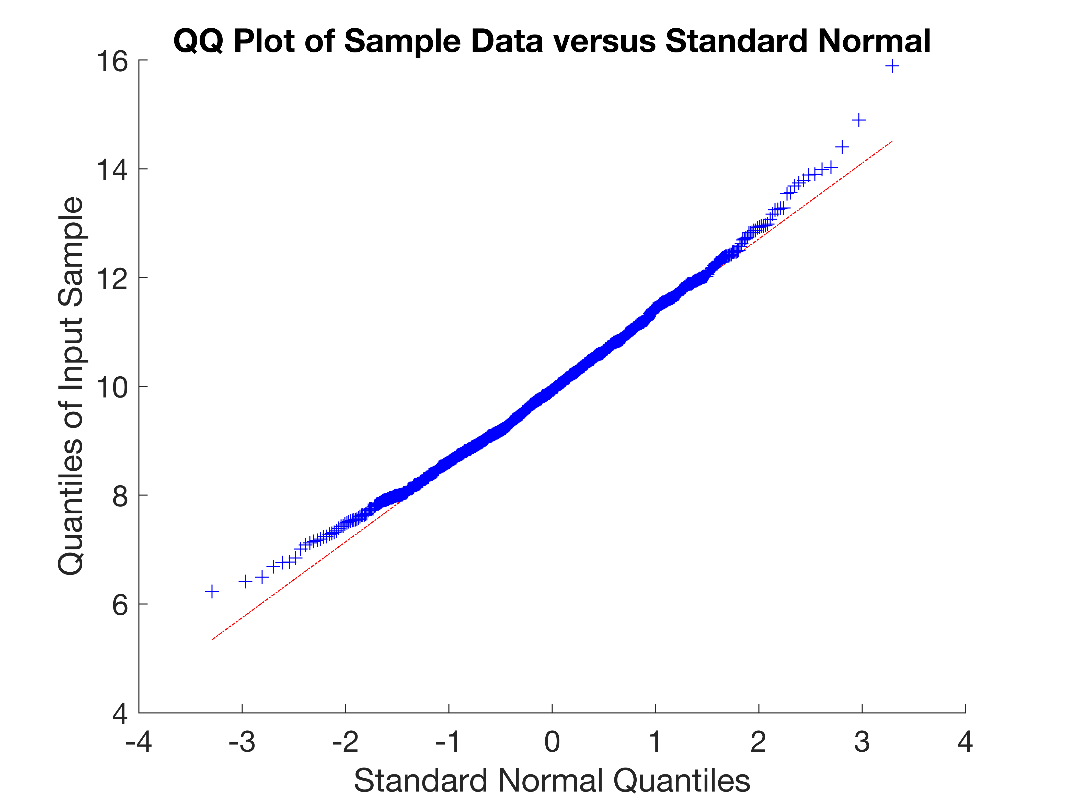

Compared to question 3, in this situation, the distribution of averages is closer to the Gaussian distribution. This is due to the central limit theory, and we have enough large sample numbers and sample times.